### **ASSIGNMENT 3**

Develop a code to upload the water tank level and light intensity values to the IBM IoT platform and visualize them in the web application.

NODE RED

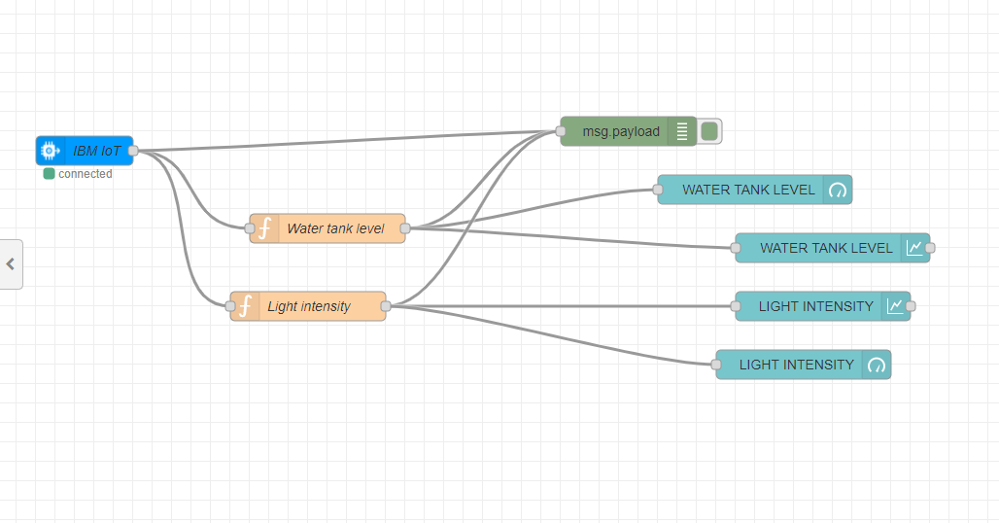

DEBUG

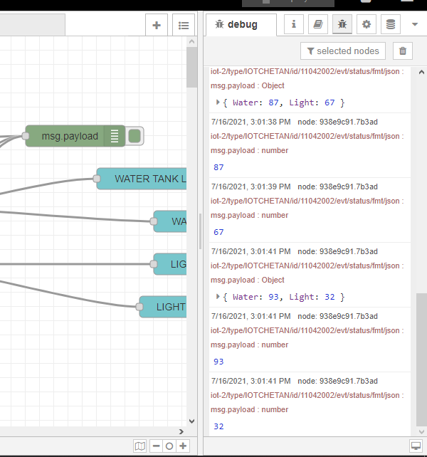

PYTHON SHELL

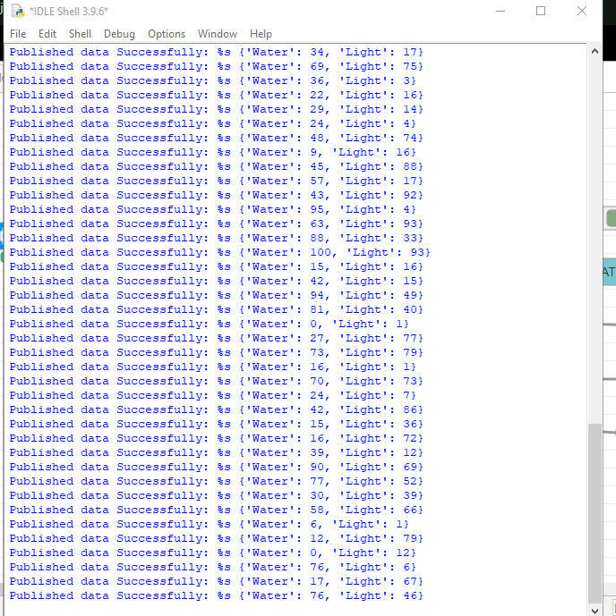

OUTPUT CHART AND GAUGE

